1.) Use the file ‘Ques1’.

Description: A sample of 40 right-handed introductory psychology students at a large southwestern university was collected. Subjects took four subtests (Vocabulary, Similarities, Block Design, and Picture Completion) of the Wechsler (1981) Adult Intelligence Scale. The researchers used Magnetic Resonance Imaging (MRI) to determine the brain size of the subjects. Information about gender and body size (height and weight) are also included. The researchers withheld the weights of two subjects and the height of one subject for reasons of confidentiality.

Variable Names:
- Gender: Male or Female
- FSIQ: Full Scale IQ scores based on the four Wechsler (1981) subtests
- VIQ: Verbal IQ scores based on the four Wechsler (1981) subtests
- PIQ: Performance IQ scores based on the four Wechsler (1981) subtests
- Weight: body weight in pounds
- Height: height in inches
- MRI: total pixel Count from the 18 MRI scans
- Build a model predicting MRI with all the other variables. Interpret the coefficient of Gender.
- Identify any observations under the model in part a which are outliers. It should be clear to me how you have determined these.
- Identify any observations under the model in part a which are high leverage points. It should be clear to me how you have determined these.
- Remove these outliers and high leverage points and compare this model to the one in part a.
- Find the correlation between all the explanatory variables besides Gender. Use that correlation matrix and the output below and determine whether you believe multicollinearity is an issue in this dataset.
> vif(model1)
Gender FSIQ VIQ PIQ Weight Height
2.607162 207.681315 67.906104 55.152431 2.199301 2.777817

- Determine by hand and using R whether the FSIQ, VIQ, PIQ are jointly significant. Also provide hypothesis statements.
1.)

> IQ = read.csv(choose.files(), header=TRUE)
> attach(IQ)

> model1 = lm(MRI ~ Gender + FSIQ + VIQ + PIQ + Weight + Height)
> summary(model1)

Call:
lm(formula = MRI ~ Gender + FSIQ + VIQ + PIQ + Weight + Height)

Residuals:
Min 1Q Median 3Q Max
-81324 -26361 -8034 20883 110071

Coefficients:
Estimate Std. Error t value Pr(>|t|)
(Intercept) 164450.64 218056.88 0.754 0.4564
GenderMale 42368.74 24529.59 1.727 0.0941 .
FSIQ -9389.38 4651.64 -2.019 0.0523 .
VIQ 5388.76 2761.43 1.951 0.0601 .
PIQ 6287.51 2526.27 2.489 0.0184 *
Weight 87.02 485.55 0.179 0.8589
Height 6883.32 3207.98 2.146 0.0398 *
---
Signif. codes: 0 ‘***’ 0.001 ‘**’ 0.01 ‘*’ 0.05 ‘.’ 0.1 ‘ ’ 1

Residual standard error: 46760 on 31 degrees of freedom
(2 observations deleted due to missingness)
Multiple R-squared: 0.6521, Adjusted R-squared: 0.5847
F-statistic: 9.684 on 6 and 31 DF, p-value: 5.117e-06

# part a.)
If a person is a Male, their MRI pixel count is 42,368.74 higher than that of a female, holding all other variables constant.

> res=rstandard(model1)
> res[order(res)]
23 14 26 27 1 22 10 34 37
-1.85757235 -1.60697022 -1.45849096 -1.40239586 -0.99362626 -0.92638445 -0.74202080 -0.71998774 -0.69060653
32 25 17 40 20 11 8 35 24
-0.66405111 -0.65820067 -0.50183653 -0.47138535 -0.47024671 -0.46046100 -0.41800638 -0.35212024 -0.29970704
19 31 30 18 29 39 33 16 3
-0.18984614 -0.18266124 -0.16974008 -0.06419124 0.22552886 0.27027844 0.29793449 0.33714401 0.36610100
4 13 6 9 15 38 5 36 28
0.43091001 0.58763115 0.68572537 0.91969454 0.98882091 1.03073516 1.33745947 1.38625694 1.59623478
12 7
2.15253763 2.46881021

# part b.)
Observations 12 and 7 are outliers since their standardized residual > |2|.

> lev=hatvalues(model1)
> lev[order(lev)]
7 15 18 5 36 1 31 11 38 23
0.09084357 0.09145738 0.09632154 0.09817127 0.10282631 0.10553738 0.10616428 0.11734245 0.11777923 0.12337840
4 27 40 30 35 6 33 26 34 28
0.12659539 0.13100495 0.13213810 0.13521482 0.14223438 0.14610916 0.14694700 0.14835618 0.17740084 0.18179366
17 16 19 20 39 37 24 12 29 8
0.18493743 0.18691410 0.18909928 0.19391029 0.21067015 0.21113841 0.21502278 0.22608661 0.23229684 0.23807204
22 25 10 9 14 32 3 13
0.24586393 0.25449739 0.26786624 0.28498836 0.29385518 0.31378618 0.34950630 0.38387220

> # 3(k+1)/n = 3(6+1)/40
> 21/40
[1] 0.525

# part c.)
There are no observations that are high leverage points since no leverage value is > |0.525|.

> model1b = lm(MRI ~ Gender + FSIQ + VIQ + PIQ + Weight + Height, subset=-c(7,12))
> summary(model1b)

Call:
lm(formula = MRI ~ Gender + FSIQ + VIQ + PIQ + Weight + Height,
subset = -c(7, 12))

Residuals:
Min 1Q Median 3Q Max
-66740 -23461 -856 17091 74656

Coefficients:
Estimate Std. Error t value Pr(>|t|)
(Intercept) 249919.6 182053.6 1.373 0.1803
GenderMale 48232.4 20355.4 2.370 0.0247 *
FSIQ -5765.7 4034.4 -1.429 0.1636
VIQ 2752.1 2433.4 1.131 0.2673
PIQ 4545.1 2168.2 2.096 0.0449 *
Weight 125.6 402.6 0.312 0.7573
Height 6555.1 2654.1 2.470 0.0196 *
---
Signif. codes: 0 ‘***’ 0.001 ‘**’ 0.01 ‘*’ 0.05 ‘.’ 0.1 ‘ ’ 1

Residual standard error: 38500 on 29 degrees of freedom
(2 observations deleted due to missingness)
Multiple R-squared: 0.7244, Adjusted R-squared: 0.6674
F-statistic: 12.71 on 6 and 29 DF, p-value: 5.386e-07

> summary(model1)

Call:
lm(formula = MRI ~ Gender + FSIQ + VIQ + PIQ + Weight + Height)

Residuals:
Min 1Q Median 3Q Max
-81324 -26361 -8034 20883 110071

Coefficients:
Estimate Std. Error t value Pr(>|t|)
(Intercept) 164450.64 218056.88 0.754 0.4564
GenderMale 42368.74 24529.59 1.727 0.0941 .
FSIQ -9389.38 4651.64 -2.019 0.0523 .
VIQ 5388.76 2761.43 1.951 0.0601 .
PIQ 6287.51 2526.27 2.489 0.0184 *
Weight 87.02 485.55 0.179 0.8589
Height 6883.32 3207.98 2.146 0.0398 *
---
Signif. codes: 0 ‘***’ 0.001 ‘**’ 0.01 ‘*’ 0.05 ‘.’ 0.1 ‘ ’ 1

Residual standard error: 46760 on 31 degrees of freedom
(2 observations deleted due to missingness)
Multiple R-squared: 0.6521, Adjusted R-squared: 0.5847
F-statistic: 9.684 on 6 and 31 DF, p-value: 5.117e-06

# part d.)
Gender before was not significant, now it is significant.
At alpha = 0.05, all other variables have the same significance decisions, but the p-values for FSIQ and VIQ are much worse than before.

 | Model 1 |  | Outliers removed
R² | 0.6521 |  | 0.7244 | better
R² adj | 0.5847 |  | 0.6674 | better
S | 46760 |  | 38500 | better
F p-value | 5.117E-06 |  | 5.386E-07 | better

> cor(cbind(FSIQ, VIQ, PIQ, Weight, Height), use = "pairwise.complete.obs")
FSIQ VIQ PIQ Weight Height
FSIQ 1.00000000 0.94663878 0.934125147 -0.051482850 -0.08600241
VIQ 0.94663878 1.00000000 0.778135114 -0.076088042 -0.07106813
PIQ 0.93412515 0.77813511 1.000000000 0.002512154 -0.07672318
Weight -0.05148285 -0.07608804 0.002512154 1.000000000 0.69961400
Height -0.08600241 -0.07106813 -0.076723176 0.699614004 1.00000000

# part e.)
We see that a couple of the correlations, especially between FSIQ/VIQ and FSIQ/PIQ are very high.
We also see that FSIQ, VIQ, and PIQ all have variance inflation factors over 10.
Both of these imply to us that multicollinearity is a problem in this dataset.

> model2 = lm(MRI ~ Gender + Weight + Height)
> summary(model2)

Call:
lm(formula = MRI ~ Gender + Weight + Height)

Residuals:
Min 1Q Median 3Q Max
-74818 -32306 -16290 19185 133371

Coefficients:
Estimate Std. Error t value Pr(>|t|)
(Intercept) 571204.4 217456.9 2.627 0.0128 *
GenderMale 63733.3 26694.3 2.388 0.0227 *
Weight 257.4 566.7 0.454 0.6526
Height 3894.7 3674.9 1.060 0.2967
---
Signif. codes: 0 ‘***’ 0.001 ‘**’ 0.01 ‘*’ 0.05 ‘.’ 0.1 ‘ ’ 1

Residual standard error: 55760 on 34 degrees of freedom
(2 observations deleted due to missingness)
Multiple R-squared: 0.4574, Adjusted R-squared: 0.4096
F-statistic: 9.555 on 3 and 34 DF, p-value: 0.0001016

> anova(model1, model2)
Analysis of Variance Table

Model 1: MRI ~ Gender + FSIQ + VIQ + PIQ + Weight + Height
Model 2: MRI ~ Gender + Weight + Height
Res.Df RSS Df Sum of Sq F Pr(>F)
1 31 6.7779e+10
2 34 1.0570e+11 -3 -3.7921e+10 5.7813 0.002924 **
---
Signif. codes: 0 ‘***’ 0.001 ‘**’ 0.01 ‘*’ 0.05 ‘.’ 0.1 ‘ ’ 1

> anova(model1)
Analysis of Variance Table

Response: MRI
Df Sum Sq Mean Sq F value Pr(>F)
Gender 1 8.2113e+10 8.2113e+10 37.5559 8.522e-07 ***
FSIQ 1 1.5977e+10 1.5977e+10 7.3073 0.01104 *
VIQ 1 4.6086e+09 4.6086e+09 2.1078 0.15659
PIQ 1 1.1104e+10 1.1104e+10 5.0788 0.03144 *
Weight 1 3.1655e+09 3.1655e+09 1.4478 0.23799
Height 1 1.0066e+10 1.0066e+10 4.6040 0.03984 *
Residuals 31 6.7779e+10 2.1864e+09
---
Signif. codes: 0 ‘***’ 0.001 ‘**’ 0.01 ‘*’ 0.05 ‘.’ 0.1 ‘ ’ 1

> anova(model2)
Analysis of Variance Table

Response: MRI
Df Sum Sq Mean Sq F value Pr(>F)
Gender 1 8.2113e+10 8.2113e+10 26.4128 1.133e-05 ***
Weight 1 3.5083e+09 3.5083e+09 1.1285 0.2956
Height 1 3.4919e+09 3.4919e+09 1.1232 0.2967
Residuals 34 1.0570e+11 3.1088e+09
---
Signif. codes: 0 ‘***’ 0.001 ‘**’ 0.01 ‘*’ 0.05 ‘.’ 0.1 ‘ ’ 1

# part f.)

H₀ : β_{FSIQ} = β_{VIQ} = β_{PIQ} = 0
H₁ : at least 1 β ≠ 0

41df1= p = 3
df2= n-(k+p+1) = 40-(3+3+1) = 33 – 2 observations due to missingness = 31

> qf(0.95,3,31)
[1] 2.911334

F-test statistic = (SSE_{red} - SSE_{full})/(p*s_{full}²)

F-test statistic = (1.0570e+11 - 6.7779e+10)/(3*46760²) = 5.7811

The F-test statistic = 5.7813 > F-critical value = 2.911334 So, we do reject H₀ and we do have sufficient evidence to believe that at least 1 β ≠ 0. This means that there is significant difference between the 3 variable model and the 6 variable model and that it is not ok to use the reduced model with only 3 x variables. These 3 variables are jointly significant and must stay in the model if considered as a set.

Results if you used the models with the 2 outliers removed:

> model1b = lm(MRI ~ Gender + FSIQ + VIQ + PIQ + Weight + Height, subset=-c(7,12))
> model2b = lm(MRI ~ Gender + Weight + Height, subset=-c(7,12))
> anova(model1b, model2b)
Analysis of Variance Table

Model 1: MRI ~ Gender + FSIQ + VIQ + PIQ + Weight + Height
Model 2: MRI ~ Gender + Weight + Height
Res.Df RSS Df Sum of Sq F Pr(>F)
1 29 4.2978e+10
2 32 6.7638e+10 -3 -2.466e+10 5.5465 0.003909 **
---
Signif. codes: 0 ‘***’ 0.001 ‘**’ 0.01 ‘*’ 0.05 ‘.’ 0.1 ‘ ’ 1
2.) Use the file ‘Ques2’.
Economic ability is seen as a major determinant of varying public expenditures per capita among states in 1960.
Variable Names:
- EX: Per capita state and local public expenditures ($)
- ECAB: Economic ability index, in which income, retail sales, and the value of output (manufactures, mineral, and agricultural) per capita are equally weighted.
- MET: Percentage of population living in standard metropolitan areas
- GROW: Percent change in population, 1950-1960
- YOUNG: Percent of population aged 5-19 years
- OLD: Percent of population over 65 years of age
- WEST: Western state (1) or not (0)
- Build a model that predicts economic ability, which is the principal factor under study. There is 1 large outlier, remove it. We will call this Model A after the outlier is removed.
- Construct a scatterplot matrix. Find a variable which you believe looks most like it may have a quadratic trend in it. Add this term to Model A and determine whether you believe it is significant.
- Construct a plot with a lowess line on it and state whether you believe that this plot confirms or contradicts what you decided in part b.
- Run stepwise and backwards regression and determine whether they pick the same model. Compare the models they have picked to Model A.
- Return to Model A and add an interaction term between Old and Grow. Is this interaction term significant? State your null hypothesis, alternative hypothesis and use the t score in your decision-making rule.
2.)

> Q2 = read.csv(choose.files(), header=TRUE)
> attach(Q2)

a.)

> model1 = lm(ECAB ~ EX + MET + GROW + YOUNG + OLD + WEST)
> summary(model1)

Call:
lm(formula = ECAB ~ EX + MET + GROW + YOUNG + OLD + WEST)

Residuals:
Min 1Q Median 3Q Max
-22.404 -7.225 -0.406 5.307 51.372

Coefficients:
Estimate Std. Error t value Pr(>|t|)
(Intercept) 355.84869 83.81004 4.246 0.000122 ***
EX 0.14784 0.04482 3.298 0.002016 **
MET -0.08639 0.11783 -0.733 0.467624
GROW -0.03269 0.14014 -0.233 0.816726
YOUNG -8.49384 2.04594 -4.152 0.000163 ***
OLD -6.49280 2.07101 -3.135 0.003172 **
WEST 3.48756 4.76101 0.733 0.468015
---
Signif. codes: 0 ‘***’ 0.001 ‘**’ 0.01 ‘*’ 0.05 ‘.’ 0.1 ‘ ’ 1

Residual standard error: 12.86 on 41 degrees of freedom
Multiple R-squared: 0.7085, Adjusted R-squared: 0.6659
F-statistic: 16.61 on 6 and 41 DF, p-value: 1.334e-09

> res = rstandard(model1)
> res[order(res)]
24 7 43 34 48 11
-2.26603694 -1.95324349 -1.22247551 -1.21199374 -1.19506390 -1.09855788
12 38 39 36 5 23
-1.07530753 -1.06503882 -0.85296108 -0.80260157 -0.74309975 -0.68031712
25 20 26 10 45 46
-0.57132375 -0.53424856 -0.51202966 -0.49090554 -0.39455583 -0.35615074
2 42 30 3 31 9
-0.27626321 -0.23053012 -0.21831230 -0.20247137 -0.07198533 -0.04394357
40 4 35 8 33 21
-0.02187347 0.05828816 0.16337626 0.17507364 0.20970100 0.25096611
6 29 37 32 27 13
0.28591296 0.36701076 0.38457760 0.39093600 0.40176538 0.42078004
22 19 16 17 28 44
0.51021688 0.54300608 0.68835161 0.72486622 0.78724974 0.83442359
41 14 18 15 1 47
0.83830766 0.83903396 1.21105017 1.41569901 1.43102633 4.88750812

# part a.)

> modelA = lm(ECAB ~ EX + MET + GROW + YOUNG + OLD + WEST, subset=-c(47))
> summary(modelA)

Call:
lm(formula = ECAB ~ EX + MET + GROW + YOUNG + OLD + WEST, subset = -c(47))

Residuals:
Min 1Q Median 3Q Max
-18.3910 -5.4497 -0.1732 6.5224 17.7069

Coefficients:
Estimate Std. Error t value Pr(>|t|)
(Intercept) 235.99198 57.11603 4.132 0.000178 ***
EX 0.14940 0.02932 5.096 8.71e-06 ***
MET 0.02828 0.07858 0.360 0.720801
GROW -0.17506 0.09362 -1.870 0.068828 .
YOUNG -5.37363 1.40182 -3.833 0.000438 ***
OLD -3.28409 1.42102 -2.311 0.026064 *
WEST -0.72104 3.16455 -0.228 0.820925
---
Signif. codes: 0 ‘***’ 0.001 ‘**’ 0.01 ‘*’ 0.05 ‘.’ 0.1 ‘ ’ 1

Residual standard error: 8.413 on 40 degrees of freedom
Multiple R-squared: 0.7496, Adjusted R-squared: 0.712
F-statistic: 19.96 on 6 and 40 DF, p-value: 1.258e-10

# part b.)

> plots = data.frame(EX,MET,GROW,YOUNG,OLD,ECAB)
> pairs(plots, upper.panel=NULL)

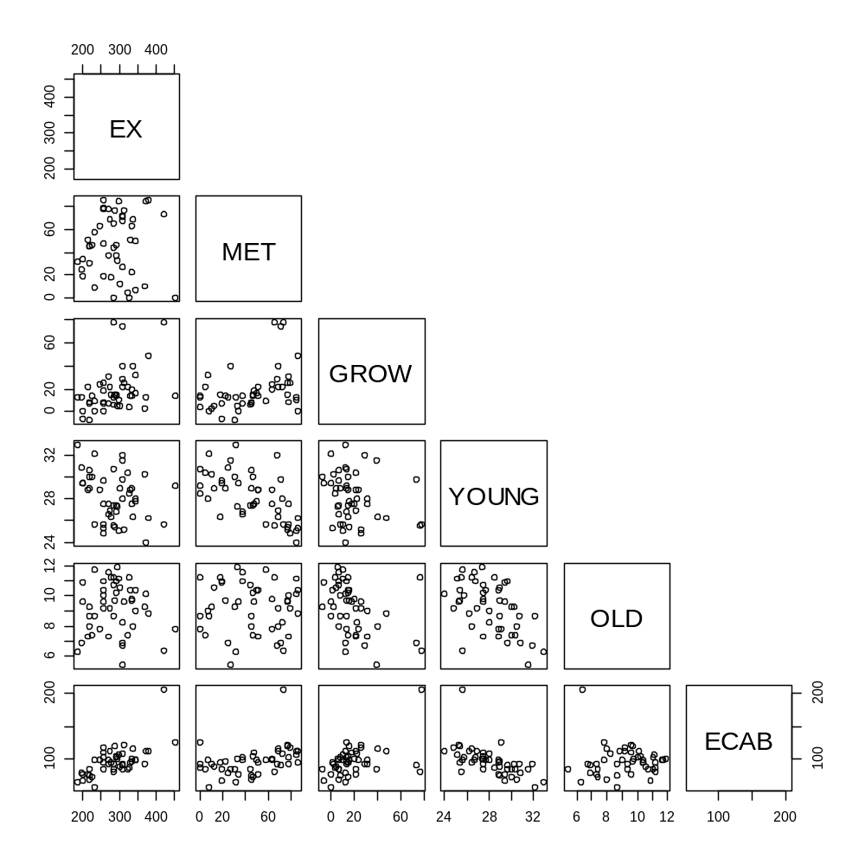

> GROW2 = GROW*GROW

> modelA2 = lm(ECAB ~ EX + MET + GROW + GROW2 + YOUNG + OLD + WEST, subset=-c(47))
> summary(modelA2)

Call:
lm(formula = ECAB ~ EX + MET + GROW + GROW2 + YOUNG + OLD + WEST,
subset = -c(47))

Residuals:
Min 1Q Median 3Q Max
-14.9421 -6.3032 0.1849 4.4283 14.6140

Coefficients:
Estimate Std. Error t value Pr(>|t|)
(Intercept) 174.591629 59.922256 2.914 0.00589 **
EX 0.136125 0.028307 4.809 2.28e-05 ***
MET 0.045443 0.074732 0.608 0.54666
GROW 0.425523 0.267864 1.589 0.12023
GROW2 -0.007707 0.003244 -2.376 0.02251 *
YOUNG -4.009656 1.445760 -2.773 0.00847 **
OLD -1.081256 1.633646 -0.662 0.51195
WEST -1.620258 3.019220 -0.537 0.59456
---
Signif. codes: 0 ‘***’ 0.001 ‘**’ 0.01 ‘*’ 0.05 ‘.’ 0.1 ‘ ’ 1

Residual standard error: 7.964 on 39 degrees of freedom
Multiple R-squared: 0.7813, Adjusted R-squared: 0.742
F-statistic: 19.9 on 7 and 39 DF, p-value: 4.694e-11

This term is significant since its p-value is 0.02251 < alpha = 0.05.

# part c.)

> residuals=residuals(modelA)
> plot(GROW, residuals)
Error in xy.coords(x, y, xlabel, ylabel, log) :
'x' and 'y' lengths differ

> residuals=residuals(model1)
> plot(GROW, residuals)
> lines(lowess(GROW, residuals))

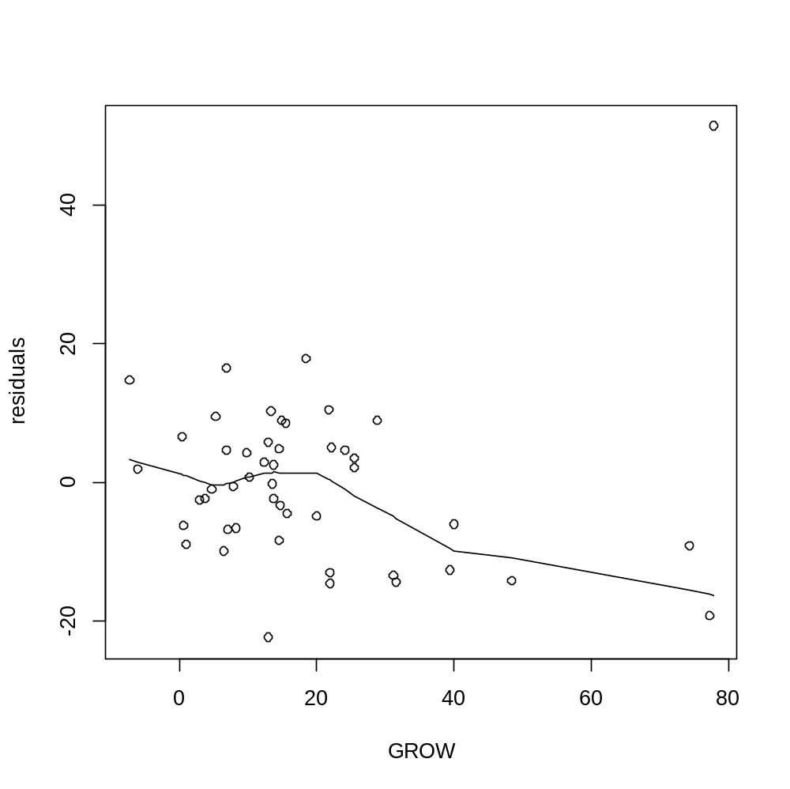
This lowess line does confirm that there is a significant quadratic trend in GROW since there is a bend in the residual plot vs. GROW here.

# part d.)

> step(modelA)
Start: AIC=206.62
ECAB ~ EX + MET + GROW + YOUNG + OLD + WEST

Df Sum of Sq RSS AIC
- WEST 1 3.67 2835.0 204.68
- MET 1 9.17 2840.5 204.77
<none> 2831.3 206.62
- GROW 1 247.50 3078.8 208.56
- OLD 1 378.06 3209.4 210.51
- YOUNG 1 1040.11 3871.4 219.33
- EX 1 1838.20 4669.5 228.14

Step: AIC=204.68
ECAB ~ EX + MET + GROW + YOUNG + OLD

Df Sum of Sq RSS AIC
- MET 1 8.32 2843.3 202.82
<none> 2835.0 204.68
- GROW 1 259.10 3094.1 206.79
- OLD 1 460.77 3295.8 209.76
- YOUNG 1 1358.16 4193.2 221.08
- EX 1 2274.18 5109.2 230.37

Step: AIC=202.82
ECAB ~ EX + GROW + YOUNG + OLD

Df Sum of Sq RSS AIC
<none> 2843.3 202.82
- GROW 1 250.8 3094.1 204.79
- OLD 1 706.9 3550.2 211.26
- EX 1 2536.9 5380.2 230.80
- YOUNG 1 3575.6 6418.9 239.09

Call:
lm(formula = ECAB ~ EX + GROW + YOUNG + OLD, subset = -c(47))

Coefficients:
(Intercept) EX GROW YOUNG OLD
255.0847 0.1429 -0.1716 -5.8412 -3.6284

# Start Backward Regression

> modelA = lm(ECAB ~ EX + MET + GROW + YOUNG + OLD + WEST, subset=-c(47))
> summary(modelA)

Call:
lm(formula = ECAB ~ EX + MET + GROW + YOUNG + OLD + WEST, subset = -c(47))

Residuals:
Min 1Q Median 3Q Max
-18.3910 -5.4497 -0.1732 6.5224 17.7069

Coefficients:
Estimate Std. Error t value Pr(>|t|)
(Intercept) 235.99198 57.11603 4.132 0.000178 ***
EX 0.14940 0.02932 5.096 8.71e-06 ***
MET 0.02828 0.07858 0.360 0.720801
GROW -0.17506 0.09362 -1.870 0.068828 .
YOUNG -5.37363 1.40182 -3.833 0.000438 ***
OLD -3.28409 1.42102 -2.311 0.026064 *
WEST -0.72104 3.16455 -0.228 0.820925
---
Signif. codes: 0 ‘***’ 0.001 ‘**’ 0.01 ‘*’ 0.05 ‘.’ 0.1 ‘ ’ 1

Residual standard error: 8.413 on 40 degrees of freedom
Multiple R-squared: 0.7496, Adjusted R-squared: 0.712
F-statistic: 19.96 on 6 and 40 DF, p-value: 1.258e-10

> modelA2 = lm(ECAB ~ EX + MET + GROW + YOUNG + OLD, subset=-c(47))
> summary(modelA2)

Call:
lm(formula = ECAB ~ EX + MET + GROW + YOUNG + OLD, subset = -c(47))

Residuals:
Min 1Q Median 3Q Max
-18.1996 -5.5473 0.0557 6.5744 17.9205

Coefficients:
Estimate Std. Error t value Pr(>|t|)
(Intercept) 241.65814 50.82010 4.755 2.46e-05 ***
EX 0.14623 0.02550 5.735 1.03e-06 ***
MET 0.02686 0.07742 0.347 0.7304
GROW -0.17772 0.09181 -1.936 0.0598 .
YOUNG -5.51416 1.24420 -4.432 6.82e-05 ***
OLD -3.39719 1.31602 -2.581 0.0135 *
---
Signif. codes: 0 ‘***’ 0.001 ‘**’ 0.01 ‘*’ 0.05 ‘.’ 0.1 ‘ ’ 1

Residual standard error: 8.315 on 41 degrees of freedom
Multiple R-squared: 0.7493, Adjusted R-squared: 0.7187
F-statistic: 24.51 on 5 and 41 DF, p-value: 2.443e-11

> modelA3 = lm(ECAB ~ EX + GROW + YOUNG + OLD, subset=-c(47))
> summary(modelA3)

Call:
lm(formula = ECAB ~ EX + GROW + YOUNG + OLD, subset = -c(47))

Residuals:
Min 1Q Median 3Q Max
-17.9675 -5.8356 0.0426 6.5748 17.7473

Coefficients:
Estimate Std. Error t value Pr(>|t|)
(Intercept) 255.08472 32.59720 7.825 9.83e-10 ***
EX 0.14287 0.02334 6.122 2.65e-07 ***
GROW -0.17162 0.08916 -1.925 0.0610 .
YOUNG -5.84117 0.80374 -7.268 6.04e-09 ***
OLD -3.62841 1.12287 -3.231 0.0024 **
---
Signif. codes: 0 ‘***’ 0.001 ‘**’ 0.01 ‘*’ 0.05 ‘.’ 0.1 ‘ ’ 1

Residual standard error: 8.228 on 42 degrees of freedom
Multiple R-squared: 0.7485, Adjusted R-squared: 0.7246
F-statistic: 31.26 on 4 and 42 DF, p-value: 4.295e-12

> modelA4 = lm(ECAB ~ EX + YOUNG + OLD, subset=-c(47))
> summary(modelA4)

Call:
lm(formula = ECAB ~ EX + YOUNG + OLD, subset = -c(47))

Residuals:
Min 1Q Median 3Q Max
-22.5763 -6.2657 0.8312 6.8334 17.3267

Coefficients:
Estimate Std. Error t value Pr(>|t|)
(Intercept) 226.78754 29.99490 7.561 2.00e-09 ***
EX 0.13123 0.02324 5.647 1.19e-06 ***
YOUNG -5.20679 0.75576 -6.889 1.86e-08 ***
OLD -2.47120 0.97774 -2.527 0.0152 *
---
Signif. codes: 0 ‘***’ 0.001 ‘**’ 0.01 ‘*’ 0.05 ‘.’ 0.1 ‘ ’ 1

Residual standard error: 8.483 on 43 degrees of freedom
Multiple R-squared: 0.7264, Adjusted R-squared: 0.7073
F-statistic: 38.05 on 3 and 43 DF, p-value: 3.627e-12

 | Model A | Stepwise | Backwards
R² | 0.7496 | 0.7485 | 0.7264
R² adj | 0.712 | 0.7246 | 0.7073
S | 8.413 | 8.228 | 8.483
F p-value | 1.258E-10 | 4.295E-12 | 3.627E-12

Model A has the variables: EX, MET, GROW, YOUNG, OLD, and WEST
Stepwise has the variables: EX, GROW, YOUNG, and OLD

Backwards has only the variables: EX, YOUNG, and OLD

# part e.)

> OG=OLD*GROW
> modelA3 = lm(ECAB ~ EX + MET + GROW + YOUNG + OLD + WEST + OG, subset=-c(47))
> summary(modelA3)

Call:
lm(formula = ECAB ~ EX + MET + GROW + YOUNG + OLD + WEST + OG,
subset = -c(47))

Residuals:
Min 1Q Median 3Q Max
-18.299 -5.758 -1.313 5.838 17.608

Coefficients:
Estimate Std. Error t value Pr(>|t|)
(Intercept) 228.79906 57.86396 3.954 0.000314 ***
EX 0.14853 0.02942 5.049 1.07e-05 ***
MET 0.01945 0.07945 0.245 0.807909
GROW 0.18887 0.42514 0.444 0.659313
YOUNG -5.38226 1.40590 -3.828 0.000456 ***
OLD -2.42232 1.73059 -1.400 0.169506
WEST -1.50935 3.29831 -0.458 0.649770
OG -0.03846 0.04382 -0.878 0.385480
---
Signif. codes: 0 ‘***’ 0.001 ‘**’ 0.01 ‘*’ 0.05 ‘.’ 0.1 ‘ ’ 1

Residual standard error: 8.438 on 39 degrees of freedom
Multiple R-squared: 0.7545, Adjusted R-squared: 0.7104
F-statistic: 17.12 on 7 and 39 DF, p-value: 4.123e-10

H₀: β_{7=OG} = 0
H₁: β_{7=OG} ≠ 0

At α = 0.05, the t-Ratio for OG = |-.878| < the critical t value = |-2.022691|, so we would Not Reject H_{o} and we would not have significant evidence that there is an interaction term between OLD and GROW.

Df=n-(k+1) = 48-(7+1) – 1 outlier removed = 39

> qt(.025, 39)
[1] -2.022691

3.) Use the file ‘Ques3’.
The given data is based on information provided by the U.S. Environmental Protection Agency. Variation in gasoline mileage among makes and models of automobiles is influenced substantially by the weight and horsepower of the vehicles.

Variable Names:
- VOL: Cubic feet of cab space
- HP: Engine horsepower
- MPG: Average miles per gallon
- SP: Top speed (mph)
- WT: Vehicle weight (100 lb)

a.) Run a one-factor ANOVA model, using WT as the factor to predict MPG.
a(i) Decide whether or not WT is an important factor in determining MPG. State your null hypothesis, alternative hypothesis and all components of the decision-making rule. Use a 5% level of significance.
a(ii) What is the point estimate of MPG when WT is 25?
a(iii) What is the 95% confidence interval for the point estimate when WT is 25?
a(iv) Interpret this interval from part a(iii).

3.)
> Q3 = read.csv(choose.files(), header=TRUE)
> attach(Q3)

> model1 = lm(MPG ~ factor(WT))
> summary(model1)

Call:
lm(formula = MPG ~ factor(WT))

Residuals:
Min 1Q Median 3Q Max
-4.6333 -1.8111 -0.7111 0.4444 16.3667

Coefficients:
Estimate Std. Error t value Pr(>|t|)
(Intercept) 49.833 1.735 28.721 < 2e-16 ***
factor(WT)22.5 -7.000 2.125 -3.294 0.00207 **
factor(WT)25 -10.156 2.240 -4.534 5.16e-05 ***
factor(WT)27.5 -13.022 2.240 -5.813 8.65e-07 ***
factor(WT)30 -18.078 2.240 -8.070 6.35e-10 ***
---
Signif. codes: 0 ‘***’ 0.001 ‘**’ 0.01 ‘*’ 0.05 ‘.’ 0.1 ‘ ’ 1

Residual standard error: 4.25 on 40 degrees of freedom
Multiple R-squared: 0.6559, Adjusted R-squared: 0.6215
F-statistic: 19.06 on 4 and 40 DF, p-value: 7.662e-09

# part a(i)

H₀ : β_{WT=22.5} = β_{WT=25} = β_{WT=27.5} = β_{WT=30} = 0
H₁ : at least 1 β ≠ 0

F p-value = 7.662e-09 < alpha = 0.05, so WT is an important factor in determining MPG.

# part a(ii)

MPG = 49.833 – 7.0(WT=22.5) - 10.156(WT=25) – 13.022(WT=27.5) – 18.078(WT=30)
= 49.833 – 7.0(0) - 10.156(1) – 13.022(0) – 18.078(0)
= 39.677

# part a(iii)

> table(WT)
WT
20 22.5 25 27.5 30
6 12 9 9 9

> dim(Q3)
[1] 45 5

> qt(.975, 40)
[1] 2.021075

95% CI for estimate of µ_{j}: (y-bar)_{j} ± t_{n-c, 1-α/2}*(s/√n_{j})
= 39.677 ± t_{45-5,.975} (4.25/√9)
= 39.677 ± 2.021075(4.25/√9)
= (36.814, 42.540)

# part a(iv)

We are 95% confident that the average MPG for all automobiles that weigh 2500 lbs would be between 36.814 and 42.540.

